

PROJECT
2020



Registration No: 2017-321 of 2017-2018
Roll No: 1641

If we lack the courage to take on the rapists, we deserve more severe punishment than they do.

STUDY OF VICTIM OF RAPE CASES IN INDIA OVER DIFFERENT STATES BY AGE GROUPS

Acknowledgement

The success and final outcome of this project required a lot of guidance and assistance from many people and I am extremely privileged to have got this all along the completion of my project. All that i have done is only due to such supervision and assistance and i would not regret to thank them.
I respect and thank Ms. Moumita Roy for providing me an opportunity to do the project work in rape cases data of year (2001-2010) and giving me all support and guidance, which made me complete the project duly. I am extremely thankful to her for providing such a nice support and guidance as my project guide. She guides me all along till the completion of my project work by providing all the necessary information for developing a good system.
I heartily thank our internal project guide Mr. Rup Kumar Paul for his guidance and suggestion during this project work.
I am thankful to and fortunate enough to get constant encouragement, support and guidance from all teaching staffs of our department which helped us in successfully completing our project work.

Date
12/06/2020

Introduction

According to Wikipedia statement experts say that a woman is victimized in every 16 minutes.
The conviction rate for rape case in India was 44.3% in 1973, it down to 37.7% in 1983, and it became 26.6% in 2010 which had been dramatically decrease over the past few years which indicate poor condition of our judicial system day by day.
According to NCRB report Madhya Pradesh has the highest raw number of rape reports among Indian states, while delhi has the highest per capita rate of rape reports.

Contents

- Objectives
- Data Description
- Methodology
- Data Analysis
- Conclusion
- Reference
- Appendix

Objectives

- To understand the data properly we want to plot the data in a diagrammatic format
- Our project first objective is to see that whether there is any association between victim of rape case with age groups and states
- If there is any association then we want to see that over the different states and different type of rape cases which specific age group has been victimised most

Data Description

I collected the data from Kaggle website. In my data there are 12 columns and 1051 rows. The first column gives us the different names of states of India. The second column gives the corresponding year of rape case reported. The third column gives the type of rape cases and total rape case victims. The fourth column gives the reported cases. The fifth column gives the number of cases happens to the women of age of above 50 year. The sixth column give the number of cases happens to the women of ages between 10-14 year. The seventh column gives the number of cases happens to the women of age between 14-18 year. The eighth column give the number of cases happens to the women of ages between 18-30 year. The ninth column gives the number of cases happens to the women of ages between 30-50 year. The eleventh column give the number of cases happens to the women of ages between 0-14 year. The 12th column gives the total number of cases that has been reported throughout the year in different states in India. The data is given for the year 2001-2010. We process the data to obtaining our objective. For our first objective we need to done two chi-square tests so we create two data set from the raw data. For the first test we group the data by states so we have 36 states and there corresponding rape case of different age groups throughout the years 2001-2010 and for second test we group the data by type of rape case (subgroup) so we have 2 types and there corresponding reported case for different age groups throughout the years 2001-2010.A sample of the data and link of the data is given on the appendix .

Methodology

The method that I have used in my project is the method of chi-square test of independence of attribute. Why? I use this there are several reasons behind it. First and fore most in my data there are categorical variables and my project objective is to see that weather there is any relation between any of the categories. The chi-square test of independence is used to determine if there is a significant relationship between two nominal (categorical) variables. The frequency of each category for one nominal variable is compared across the categories of the second nominal variable.
The basic criteria for using chi-square is that – the sampling method that has been used it should be simple random sampling ,the variables under study should be categorical variables and if sample data are displayed in a contingency table, the expected frequency count for each cell of the table is at least 5 .
This approach consists of three steps: (1) state the hypotheses, (2) analyse sample data, and (3) interpret results.
(1) state the hypothesis
Suppose that variable A has r levels , and variable B has c levels .The null hypothesis states that knowing the level of variables A does not help you predict the level of the variable B .That the variables are independent .The alternative hypothesis is that knowing the level of variable A can help you to predict the level of variable B .
(2) analyse sample data
Using sample data, we find the degree of freedom, expected frequencies, test statistics and p-value associated with the test statistics.
Degree of freedom-The degrees of freedom (DF) is equal to:
DF=(r-1)*(c-1)
where r the number of levels for one categorical variable, and c is the number of levels for the other categorical variable.
Expected frequencies-The expected frequency counts are computed separately for each level of one categorycal variable at each level of the other categorical variable .Compute r*c expected frequencies, according to the following formula
E_{r,c}=(n_{r}*n_{c})/n
where E_{r,c} is the expected frequency count for level r of variable A and level c of variable B, n_{r} is the total number of sample observations at level r of variable A, n_{c} is the total number of sample observation at level c of variable B and n is the total sample size.
Test statistics-The test statistics is a chi-square random variable(X²) define by the following equation
X²=Σ[(O_{r,c}-E_{r,c})²/E_{r,c}]
where O_{r,c} is the observed frequency count at level rof variable A and level c of variable B,and E_{r,c} is the expected frequency count at level r of variable A and level c of variable B .
P-value- The P-value is the probability of observing a sample statistic as extreme as the test statistic. Since the test statistic is a chi-square, use the chi-square distribution table to assess the probability associated with the test statistic using the degree of freedom computed above.
(3)interpret results
If the sample findings are unlikely ,given the null hypothesis ,the researcher rejects the null hypogthesis .Typically ,this involves comparing the P-value to the significance level, and reject the null hypothesis when the P-value is less than the significance level and add in alternative hypothesis variables are associated .
After doing the chi-square test we create the resedual table and from that table we see that some of the cell values are grater than 3 so we conclude that the corrosponding row and columns are associated with each

Data Analysis

Bar diagram of rape cases of different age grouped victims between the years 2001-2010
code-
library(dplyr)
library(ggplot2)
a<-read.csv("/home/amit/Desktop/test(p).csv")
#First Bar diagram
g<-a%>%
select(Area_Name,Victims_Upto_10_Yrs)%>%
group_by(Area_Name)%>%
filter(Victims_Upto_10_Yrs>22)

ggplot(g,aes(Area_Name,Victims_Upto_10_Yrs))+geom_bar(aes(Area_Name,Victims_Upto_10_Yrs,fill=Area_Name),stat="identity",width=0.5)+coord_flip()+ggtitle("Reported rape case of victims of age between (0-10)year in different states of India")+theme(legend.position = 'none')
#Second Bar diagram
m<-a%>%
select(Area_Name,Victims_Between_10.14_Yrs)%>%
group_by(Area_Name)%>%
filter(Victims_Between_10.14_Yrs>30)

ggplot(m,aes(Area_Name,Victims_Between_10.14_Yrs))+geom_bar(aes(Area_Name,Victims_Between_10.14_Yrs,fill=Area_Name),stat = "identity",width=0.5)+coord_flip()+ggtitle("Reported rape case of victims of age between 10-14 in different state of India")+theme(legend.position = 'none')
Output :
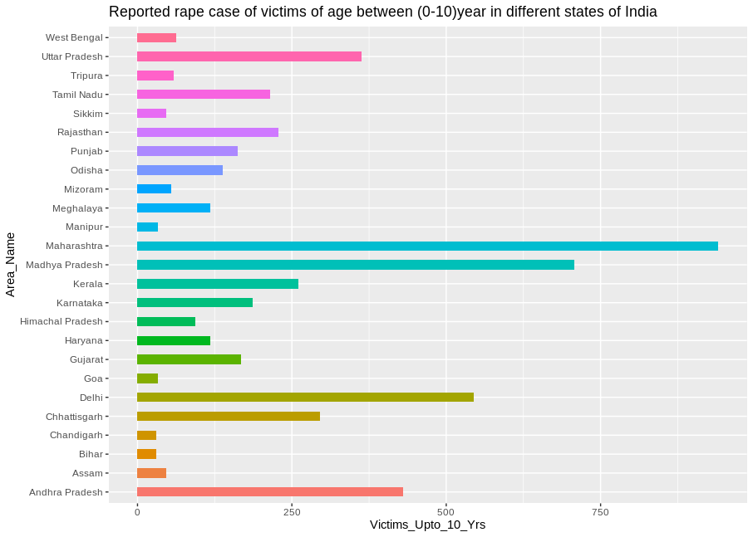
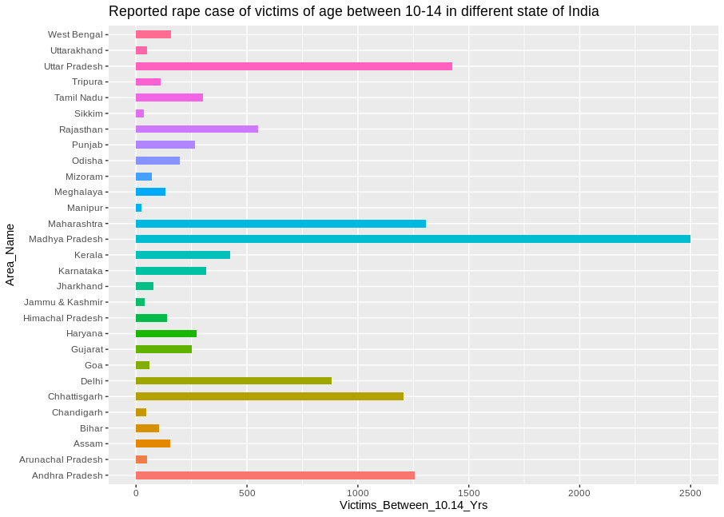

From the first the bardiagram we can see that the age group of (0-10) year victimize most in Maharastra and Madhya Pradesh.From the second bardiagram we can interpret that the age group of (10-14) year victimize most in Madhya Pradesh .
Code-
#Third Bar diagram
o<-a%>%
select(Area_Name,Victims_Between_14.18_Yrs)%>%
group_by(Area_Name)%>%
filter(Victims_Between_14.18_Yrs>30)

ggplot(o,aes(Area_Name,Victims_Between_14.18_Yrs))+geom_bar(aes(Area_Name,Victims_Between_14.18_Yrs,fill=factor(Area_Name)),stat = "identity",width=0.6)+coord_flip()+ggtitle("Reported rape cases of victims of age group between (14-18)year in different states of India")+theme(legend.position = 'none')
#Fourth Bar diagram
n<-a%>%
select(Area_Name,Victims_Between_18.30_Yrs)%>%
group_by(Area_Name)%>%
filter(Victims_Between_18.30_Yrs>30)
ggplot(n,aes(Area_Name,Victims_Between_18.30_Yrs))+geom_bar(aes(Area_Name,Victims_Between_18.30_Yrs,fill=factor(Area_Name)),stat="identity",width=0.5)+coord_flip()+ggtitle("Reported rape case of victims of age between (18-30)year in different states of India")+theme(legend.position = 'none')
Output :
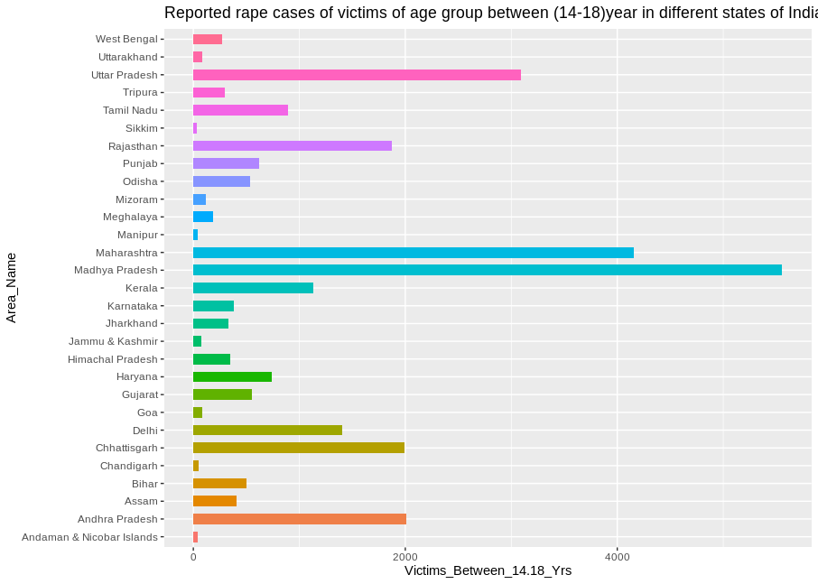
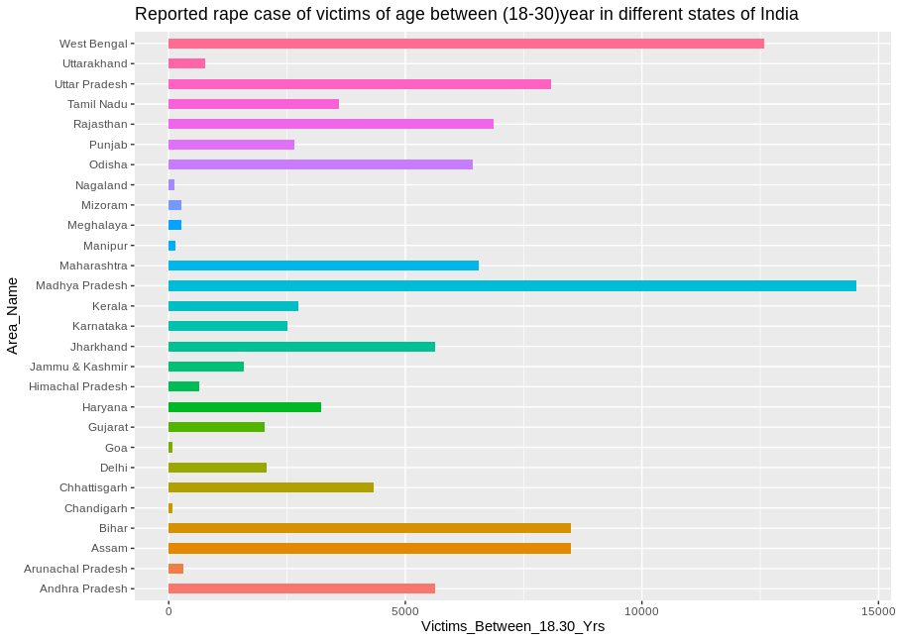

From the Third Bar diagram we can see that the age group (14-18)year victimize most in Madhya Pradesh.From the Fourth Bar diagram we can see that the age group (18-30) year victimize most in West Bengail and Madhya Pradesh.

Code-
#Fifth Bar diagram
s<-a%>%
select(Area_Name,Victims_Between_30.50_Yrs)%>%
group_by(Area_Name)%>%
filter(Victims_Between_30.50_Yrs>30)
ggplot(s,aes(Area_Name,Victims_Between_30.50_Yrs))+geom_bar(aes(Area_Name,Victims_Between_30.50_Yrs,fill=Area_Name),stat="identity",width=0.5)+coord_flip()+ggtitle("Reported rape case of victims of age between (30-50)year in different states of India")+theme(legend.position = 'none')
#Sixth Bar diagram
mon<-a%>%
select(Area_Name,Victims_Above_50_Yrs,Victims_Between_10.14_Yrs)%>%
group_by(Area_Name)%>%
filter(Victims_Above_50_Yrs>30)

ggplot(mon,aes(Area_Name,Victims_Above_50_Yrs))+geom_bar(aes(Area_Name,Victims_Above_50_Yrs,fill=factor(Area_Name)),stat = "identity",width=0.5)+coord_flip()+ggtitle("Reported rape cases of above 50 year age group victims in different states of India")+theme(legend.position = 'none')
Output:

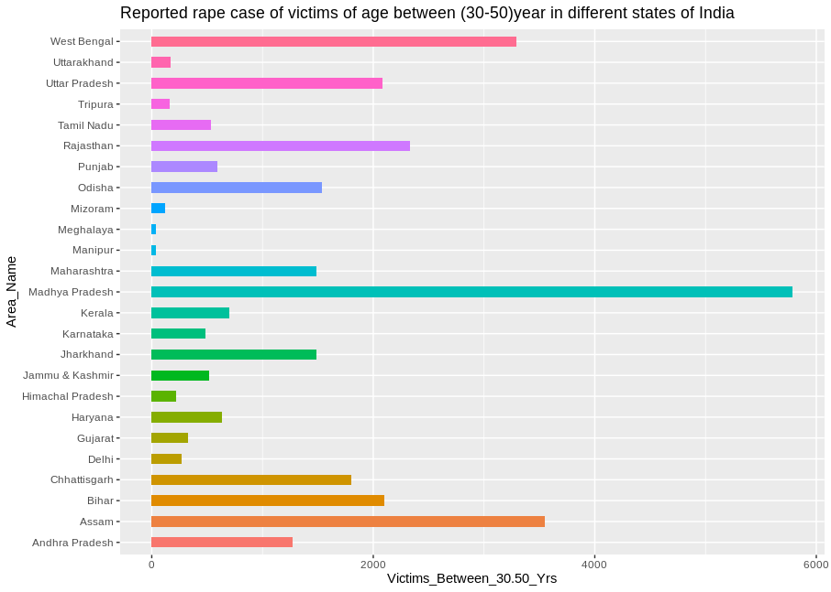
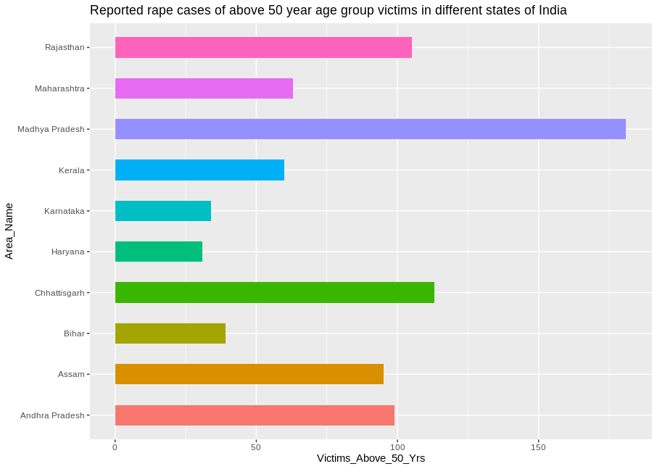

From the Fifth Bar diagram we can see that the age group (30-50) year victimize most in Madhya Pradesh. From the Sixth Bar diagram we can see that the age group over 50 year Victimize most in Madhya Pradesh.

Bar diagram of different type of rape case over the different age group throughout the year 2001 to 2010
Code-
s<-read.csv("/home/amit/Desktop/separet 1(incest).csv")
i<-read.csv("/home/amit/Desktop/speparet 2(other).csv")
View(i)
s%>%
ggplot(aes(x=Age_group,y=Victims.of.Incest.Rape,fill=Age_group))+geom_bar(stat="identity",color="black")+ggtitle("Victim of incest rape case through out the year of 2001-2010")
i%>%
ggplot(aes(x=Age_group,y=Victims.of.Other.Rape,fill=Age_group))+geom_bar(stat="identity",color="black")+ggtitle("Victim of other rape case through out the year of 2001-2010")
Output :
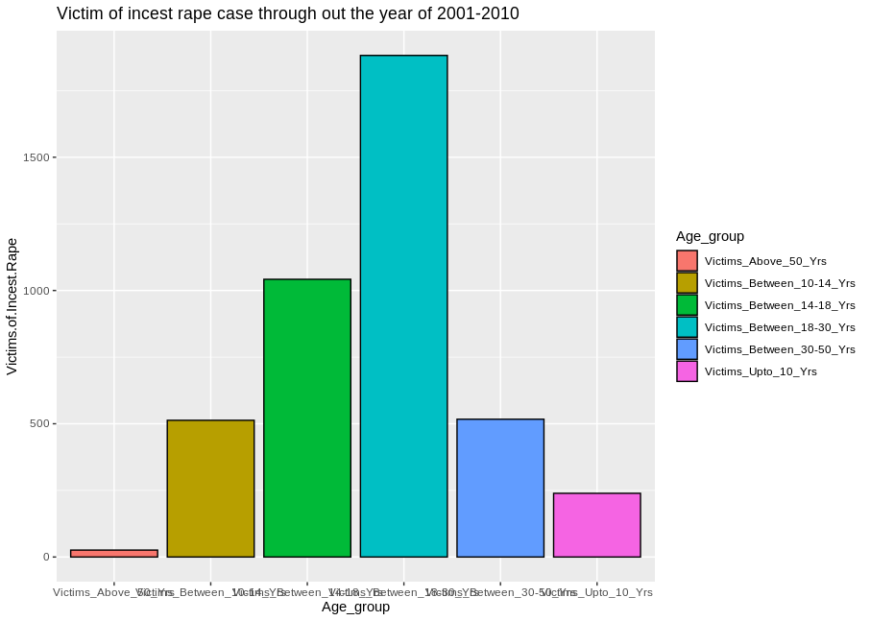
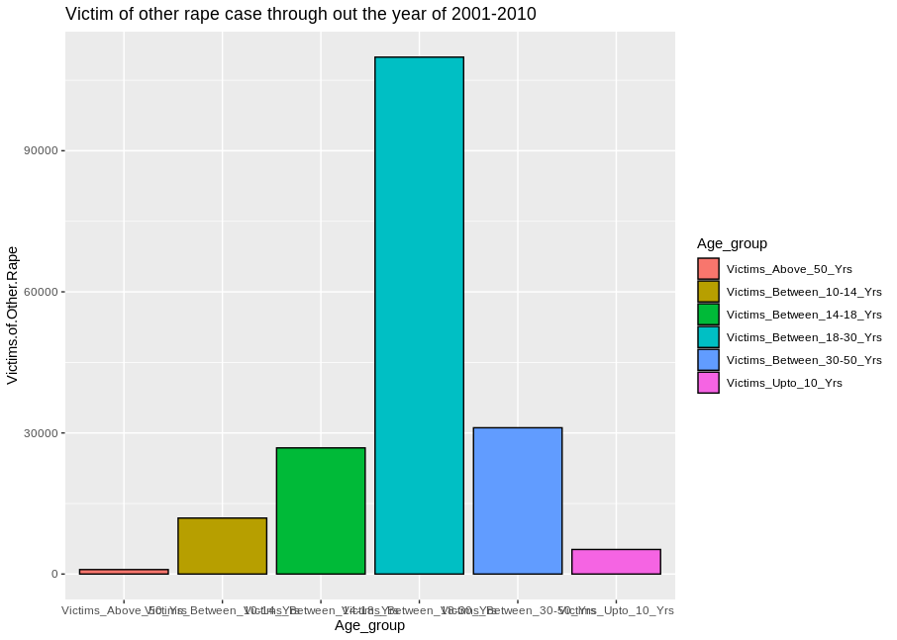
In the Incest case bar diagram we see that the age group (14-18) year and (18-30) has been victimized most .In the Other reported cases bar diagram we can see that the age group (18-30) has been victimized most rather than the other age groups.

>ch-square test
In the beginning of the data analysis, we first process the raw data into workable format which i have describe in the data description section and then we do the analysis on it.
I have done the data analysis in R language by executing the following codes
For pearson chi-square test between age group and states
a<-read.csv("/home/amit/Desktop/test(p).csv")
b<-data.frame(a)
c<-b[,2:7]
d<-as.matrix(c)
chisq.test(d)
Output-

Pearson's Chi-squared test

data: d
X-squared = 28127, df = 170, p-value < 2.2e-16
Interpretation of output – here the observe p-value is less than .005 so we reject the null hypothesis and accept the alternative hypothesis which we can say that there is a association between age group and states .
For Pearson chi-square test between age group and subgroup
e<-read.csv("/home/amit/Documents/test(sub).csv")
f<-data.frame(e)
g<-f[,2:7]
h<-as.matrix(g)
chisq.test(h)
Output-

Pearson's Chi-squared test

data: h
X-squared = 820.96, df = 5, p-value < 2.2e-16
Interpretation of output – here the observe P-value is less than 0.005 so we reject the null hypothesis and accept the alternative hypothesis which we can say that there is a association between age groups and subgroups. we now find the residuals which i have calculated in Excel Worksheet.
For the first case.

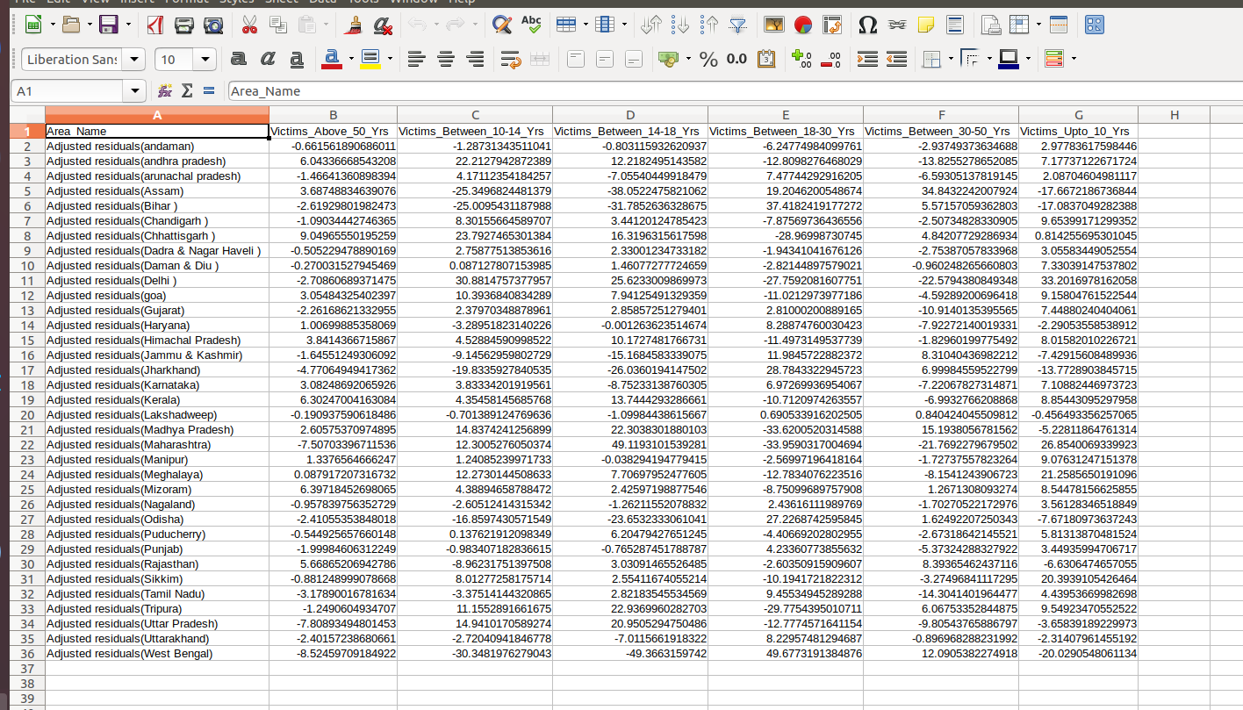

For second case -
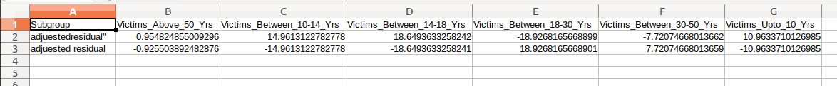
From the first table of adjusted residuals there is an association between age group and states due to following associations:
(i) Andhra Pradesh, Assam, Chhattisgarh, Himachal Pradesh, Kerala, Mizoram, Rajasthan and age group over 50 years.
(ii)Andhra Pradesh, Arunachal Pradesh, Chandigarh, Dadra And Nagar Haveli, Delhi, Goa, Himachal Pradesh, Karnataka, Kerala, Madhya Pradesh, Maharashtra, Meghalaya, Mizoram, Sikkim, Tripura, Uttar Pradesh and age group (10-14) year
(iii)Andhra Pradesh, Chandigarh, Chhattisgarh, Delhi, Goa, Himachal Pradesh, Kerala, Madhya Pradesh, Meghalaya, Puducherry, Tripura, Uttar Pradesh and age group (14-18) year
(iv)Arunachal Pradesh, Assam, Bihar, Haryana, Jammu and Kashmir, Jharkhand, Karnataka, Odisha, Punjab, Tamil Nadu, Uttarakhand, West Bengal and age group (18-30) year
(v)Assam, Bihar, Chhattisgarh, Jammu and Kashmir, Madhya Pradesh, Rajasthan, Tripura, West Bengal and age group (30-50) year
(vi)Andhra Pradesh, Chandigarh, Daman and Diu, Delhi, Goa, Gujarat, Himachal Pradesh, Karnataka, Kerala, Maharashtra, Manipur, Meghalaya, Mizoram, Nagaland, Puducherry, Punjab, Sikkim, Tamil Nadu, Tripura and age group (0-10) year
From the second table of adjusted residuals there is an association between age group and subgroup (type of rape case) due to following associations:
(i) Age groups (0-10), (10-14) ,(14-18) and Incest rape case
(ii)Age groups (18-30), (30-50) and other rape case

Conclusion

- From the diagrammatic representation we can see there might be an association in between the age groups and states, and age groups and subgroups (type of rape cases). To see is there really an association Between the nominal categorical variables we do chi-square test on the following data.
- From the result of chi-square test statistics we conclude that there is an association between age group and states ,age group and subgroup(type of rape case) .After rejecting the null hypothesis we have to find which specific age group is associated with the which specific states and with which specific subgroups(type of rape cases)
- From the table of adjusted residuals, we came to know that the specific associations for states are followings:
(i) Andhra Pradesh, Assam, Chhattisgarh, Himachal Pradesh, Kerala, Mizoram, Rajasthan and age group over 50 years.
(ii)Andhra Pradesh, Arunachal Pradesh, Chandigarh, Dadra And Nagar Haveli, Delhi, Goa, Himachal Pradesh, Karnataka, Kerala, Madhya Pradesh, Maharashtra, Meghalaya, Mizoram, Sikkim, Tripura, Uttar Pradesh and age group (10-14) year
(iii)Andhra Pradesh, Chandigarh, Chhattisgarh, Delhi, Goa, Himachal Pradesh, Kerala, Madhya Pradesh, Meghalaya, Puducherry, Tripura, Uttar Pradesh and age group (14-18) year
(iv)Arunachal Pradesh, Assam, Bihar, Haryana, Jammu and Kashmir, Jharkhand, Karnataka, Odisha, Punjab, Tamil Nadu, Uttarakhand, West Bengal and age group (18-30) year
(v)Assam, Bihar, Chhattisgarh, Jammu and Kashmir, Madhya Pradesh, Rajasthan, Tripura, West Bengal and age group (30-50) year
(vi)Andhra Pradesh, Chandigarh, Daman and Diu, Delhi, Goa, Gujarat, Himachal Pradesh, Karnataka, Kerala, Maharashtra, Manipur, Meghalaya, Mizoram, Nagaland, Puducherry, Punjab, Sikkim, Tamil Nadu, Tripura and age group (0-10) year
- From the table of adjusted residuals, we came to know that the specific associations for subgroups are followings:
(i) Age groups (0-10), (10-14), (14-18) and Incest rape case
(ii)Age groups (18-30), (30-50) and other rape case

Appendix
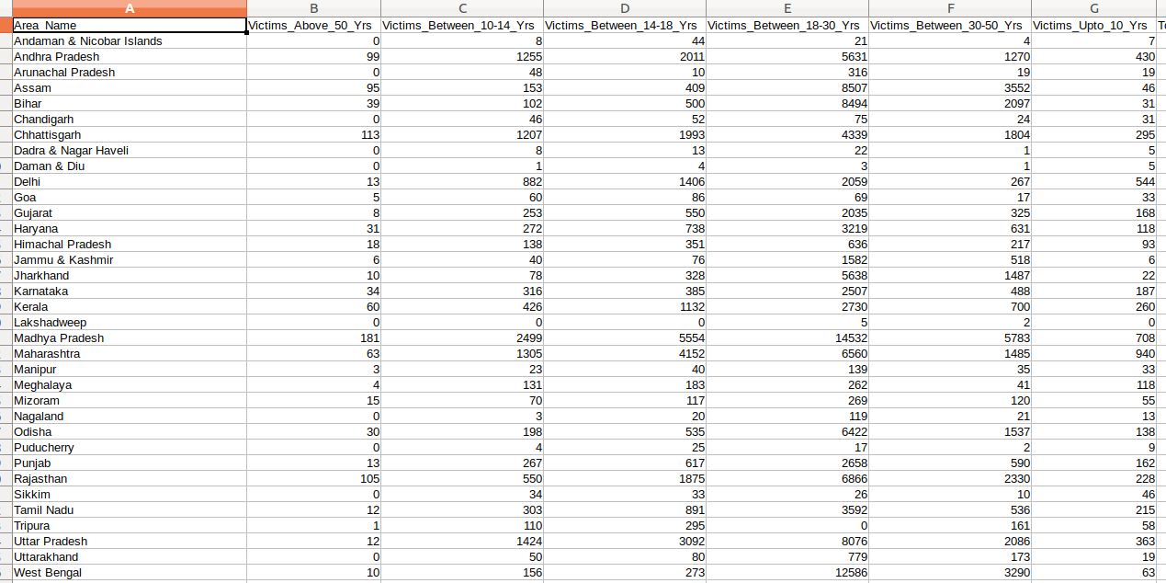

Link of the data is given -https://www.kaggle.com/rajanand/crime-in-india/data?select=20_Victims_of_rape.csv

